Lacuna Expanse Glyph / Halls Tracking
Spreadsheet based tracking of glyphs, with historical tracking and forecast of expected Halls of Vrbansk.
Features:
- Daily collection of glyph data using Windows Scheduled Task. Gathers list of all glyphs empire-wide and stores them in a cross-platform server-less database file.
- Via ODBC, Excel displays several tabbed views of the data:
  - Empire-Wide Glyph Totals
  - Planet Specific Glyph Totals – Choose a planet from a list box and the grid updates view of the five ways the glyphs can combine to form Halls of Vrbansk. Shows number of Halls that may be formed at this planet at this time.
  - Pivot table showing the empire-wide glyphs by type by date
  - Pivot table driven chart showing empire-wide quantity history of each glyph type over time.
- Spreadsheet is designed to refresh the data sources upon loading, but not automatically thereafter. Excel allows a periodic refresh, but the data doesn’t change significantly in the short term. I find a daily poll and refresh is all that I’ve needed.

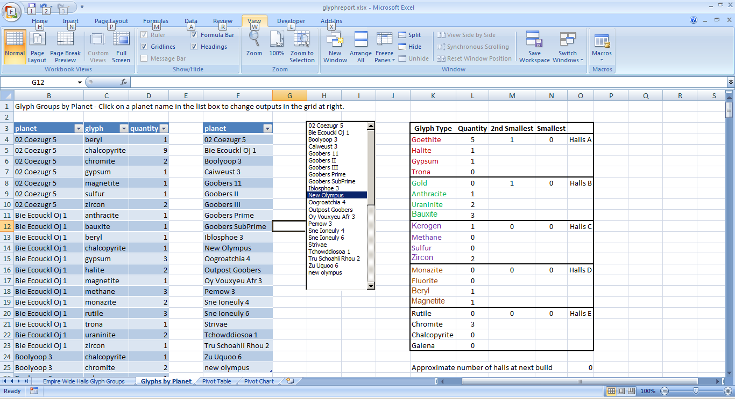
Ingredients:
- Sqlite3 (http://www.sqlite.org/download.html )
- Sqlite3 ODBC driver (http://www.ch-werner.de/sqliteodbc/ 32 bit seems to work best)
- Modified glyph_report.pl file: glyph_report_sqlite.pl – provided via github link (https://github.com/Goobers/TLE)
New command line parameter –database followed by full path to the tle.sqlite database file.
- PERL Packages (cpan for strawberry PERL or ppm for activestate PERL)
  - Games::Lacuna::Client
  - DateTime
  - DateTime::Fortmat::DBI
  - DBI with sqlite3 dbi driver
- Windows Scheduled Task to run PERL script periodically
- Excel Spreadsheet: glyphreport.xlsx. I don’t see why this can’t also be done in Open Office or Libre Office – provided via github link (https://github.com/Goobers/TLE)
- Firefox Browser (not strictly required, but makes it easy to browse the database file with Sqlite Manager)
- Sqlite Manager Plugin for Firefox
Installation:
- Assumes you already have your PERL / Games::Lacuna::Client scripting environment tested and working. There’s a lot of information about doing this, so I don’t address it here.
- Use PPM or CPAN to add the listed PERL packages
- Place glyph_report_sqlite.pl in your c:\myperl\tsee\examples directory or wherever you keep your scripts.
- Download and install Sqlite3 and Sqlite3 ODBC driver. Optionally, you can install the Sqlite Manager plugin for Firefox or some equivalent Sqlite3 management tool. This will be useful if you wish to create new views to the database with which to feed data to your spreadsheet.
- Add ODBC user data source via Windows Control Panel / Administrative Tools / Data Sources (ODBC). Name it TLE or the spreadsheet won’t reference it properly. See screen shots below:
  - Shows ODBC Driver installed from the Drivers tab
  - Shows the TLE data source and its properties as they exist on my system. The filename and path of the database are up to you, but the User Data Source Name (DSN) must be named TLE, as this is referenced by the spreadsheet.
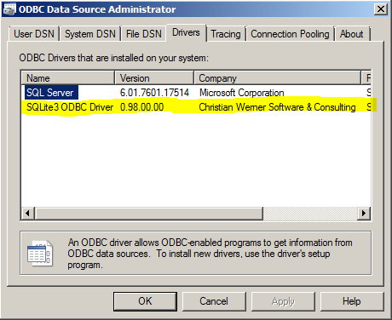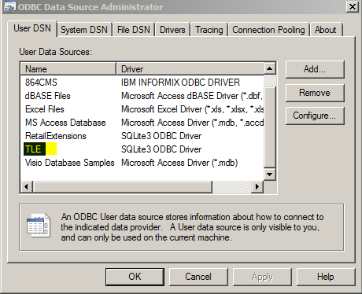
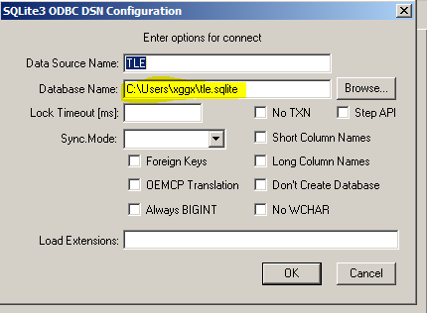
- Download and place the spreadsheet in an appropriate place.
- Also from Control Panel / Administrative tools, you should set up your Task Scheduler. I set a daily task with these parameters:
5:43 AM Daily (or best time for your needs)
Run: C:\myperl\tsee\examples\glyph_report_sqlite.pl
Arguments: --database Full_path_to_your_database
e.g. –database c:\user\tle.sqlite
- Run the script manually the first time. Look for messages indicating missing PERL packages or other script errors. You should see the output of the glyph_report.pl script as normal. If the database file was not found you should see messages to indicate this as well. If not, use the Sqlite Manager plugin within Firefox to browse the database to see if data exists in the glyph_history table. If it is not there, we have a script issue. If it is, we likely have a problem with the ODBC data source definition. Is the name correct?
- I haven’t locked anything in the spreadsheet, so if you decide you want to modify it, keep a reference copy in case you break something, or reload from git.
- Over time, you may collect more data points than you want to deal with in the spreadsheet. If this becomes a problem, you may e-mail Goobers within the game and I’ll develop some limits for the database view that feeds the pivot table and the pivot chart on the third and fourth tabs of the spreadsheet.
- Enjoy.

